**CS 455: Homework #4 – Decision Trees and Ensemble Concepts**

**Due: 4/8/2018**

For this assignment, you must submit your work at the start of class on 4/8/2018. You may work with one partner on this assignment. If you work with a partner, only one submission is required.

**Problem #1: Decision Tree Classifier**



1. [True or False] The depth of the tree above is three. **[2 points]**
2. For the decision tree above, calculate the Gini for each node. **[14 points]**
3. For the decision tree above, calculate the entropy for each node. **[14 points]**
4. Using the CART cost function, what is the cost of the left most node with depth=1 (root’s left child) of the tree above? **[5 points]**
5. What is the prediction made for an input with height=64 and width=22 using the decision tree above **[5 points]**

**Problem #2: Decision Tree Regressor [40 points]**

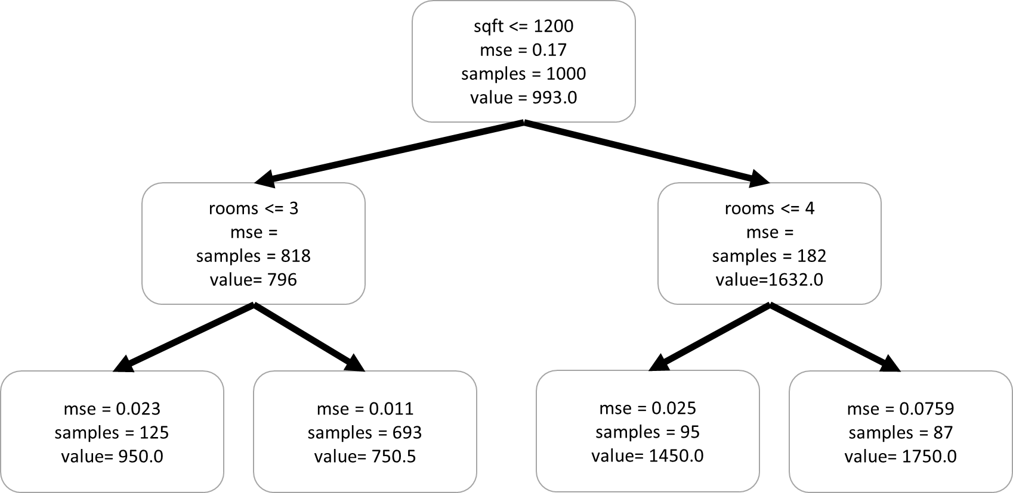

1. For the regression decision tree shown above, what would be the prediction for a house with sqft=1975 and rooms=3 **[10 points]?**
2. For your answer to b, what is the mean squared error associated with the node making the prediction? **[10 points]**
3. For the regression decision tree shown above, what would be the prediction for a house with sqft=1150 and rooms=4? **[10 points]**
4. For your answer to c, what is the mean square error for the node that made the prediction? **[10 points]**

**Problem #3: Ensemble Methods**

1. What is the difference between bagging and pasting? **[5 points]**
2. What is a decision stub? Why might you choose to use one for an ensemble? **[5 points]**
3. What are boosting ensembles? Discuss general properties of this type of ensemble and then compare and contrast between AdaBoost and Gradient Boosting **[10 points]**

**Note: there is no programming for this assignment, but you are STRONGLY encouraged to explore the concepts taught in class by running Dr. Stansbury and the textbook author’s GitHub examples, modify those models, and build your own**